SPRINT 1 SUBMISSION

DATA COLLECTION | DATA UPLOADING | DATA MODULE CREATION | DATA EXPLORATION

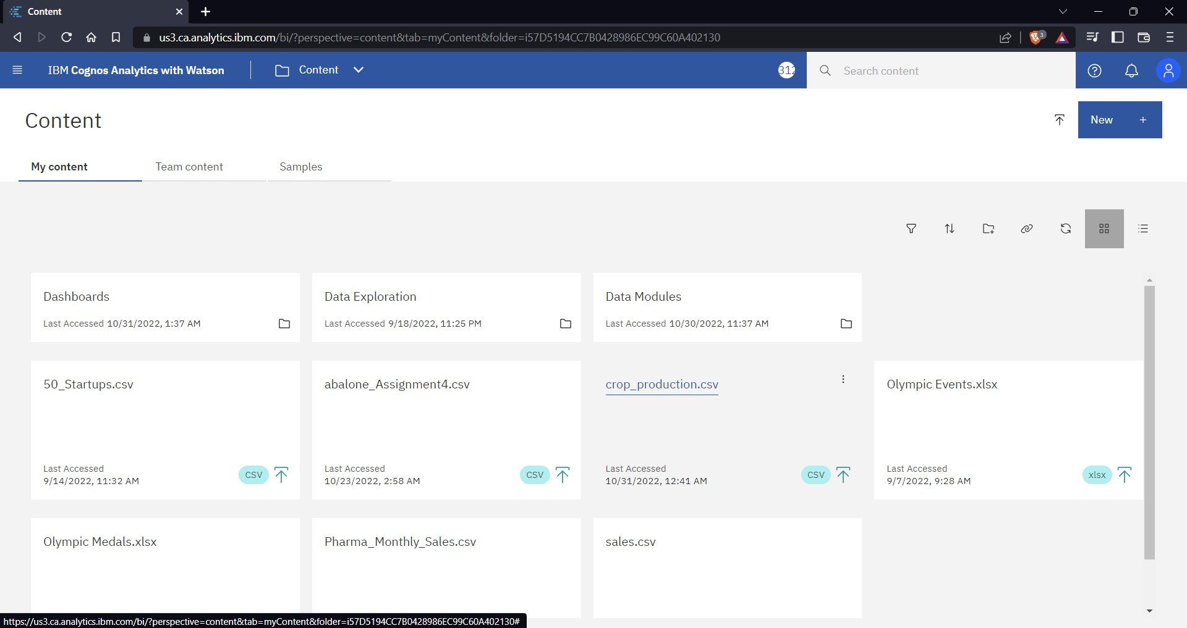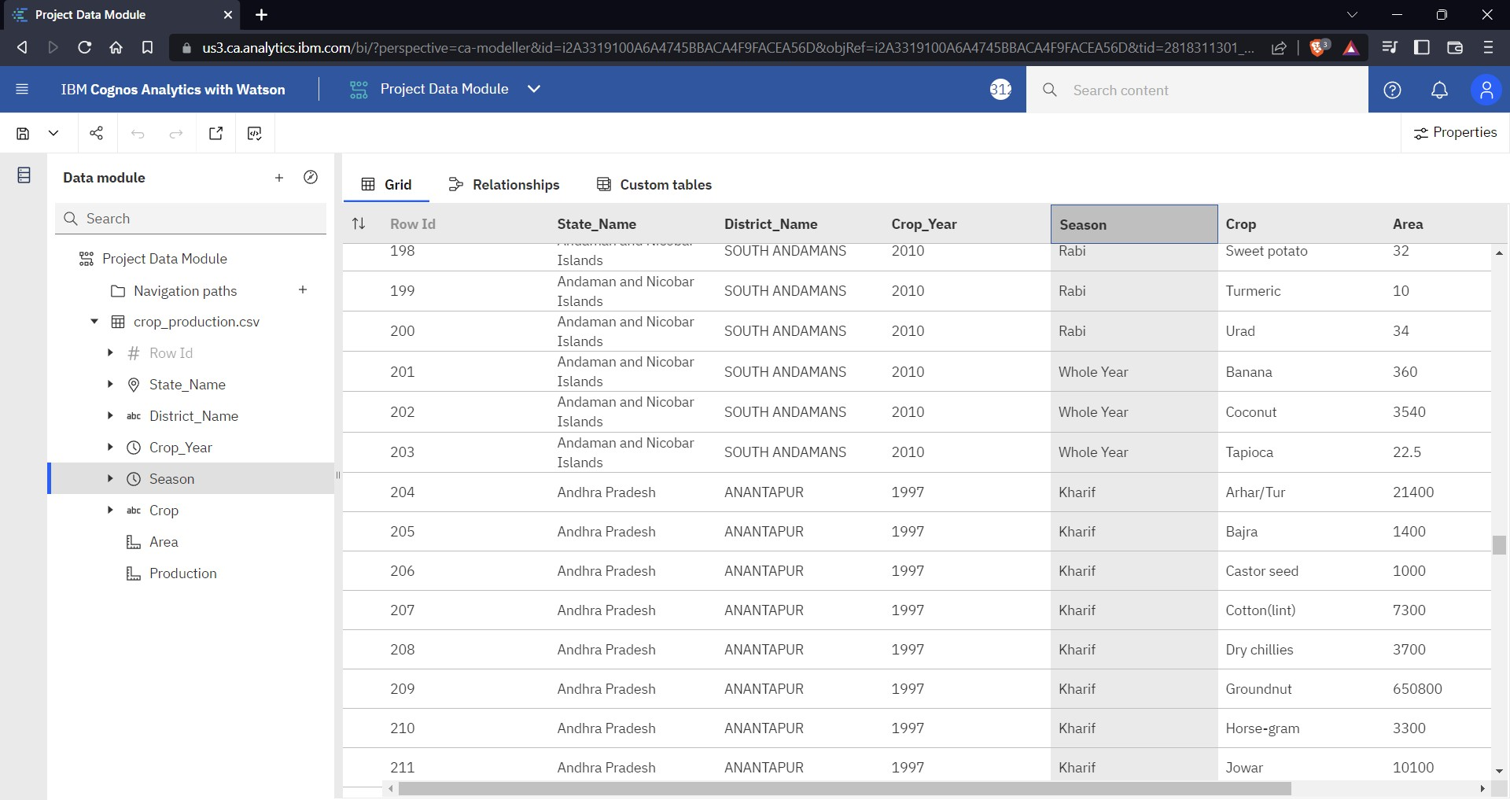

DATA MODULE CREATION

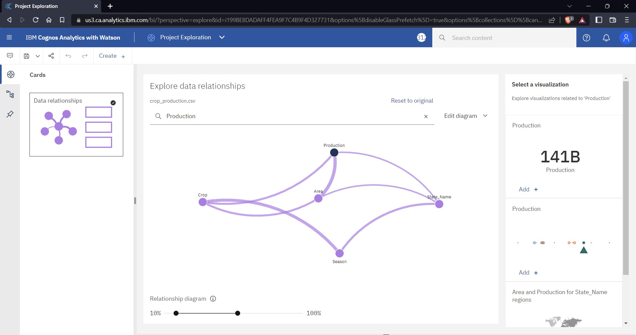

DATA EXPLORATION

